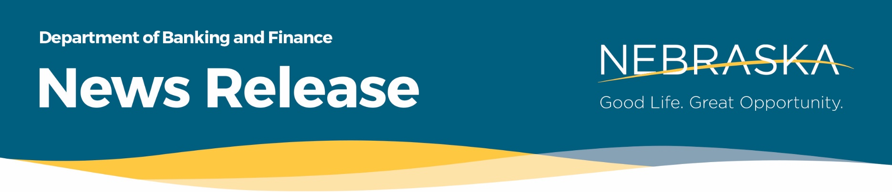

FOR IMMEDIATE RELEASE
CONTACT Melissa Berglund, Public Information Officer
Phone 402-471-2171
Email melissa.berglund@nebraska.gov

Governor Pillen Proclaims April as Financial Awareness Month
April 05, 2024 (LINCOLN, NE) – On April 4th, Gov. Jim Pillen proclaimed the month of April as Financial Awareness Month in Nebraska. The proclamation recognizes the importance of financial awareness to Nebraskans and Nebraska’s status as a leader in financial innovation, financial literacy education, and consumer and vulnerable adult protection.
The month-long financial awareness campaign is an initiative from the Nebraska Council on Economic Education (NCEE) and the Nebraska Department of Banking and Finance (NDBF). Working together, the chartered and licensed financial industries, NCEE, and NDBF will be conducting a variety of educational activities in schools, workplaces, and communities this month, and throughout the year, to educate Nebraskans about the importance of setting goals, making wise financial decisions, and protecting yourself and your financial future.
“Financial awareness is worthy of celebration. The concept of having options when saving, investing, and spending time and resources is exciting. We all make choices with our money that make a difference to our community, as well as to our personal financial health. Your decisions today will impact on your spending and quality of life tomorrow. Today is a great day to celebrate Financial Awareness,” NDBF Director Kelly Lammers said. “Financial awareness isn’t necessarily studying, it’s thinking about your future, your non-profit, and your community with a consideration as what could you do to make a difference. Nebraska’s communities have inspired visionary lawmakers to pass legislation such as Protecting Vulnerable Adults from Financial Exploitation Act and the Nebraska Financial Innovation Act. With financial literacy in mind, these laws are enabling people to make decisions today to plan for tomorrow.”
One of NCEE’s signature programs is the Nebraska In-School Savings Program. These programs give select upper elementary students an opportunity to gain job skills working as school branch tellers. Student tellers from several Nebraska in-school savings programs joined in the proclamation signing celebration. All students in schools with a savings programs are given the opportunity to participate and save weekly. Students are rewarded with incentives for frequency of saving (not amounts), as the program is designed to reward and instill the habit of saving.
“Financial literacy is not just about managing money; it’s about empowering individuals to make informed decisions about their finances, paving the way for a brighter future. The return on investment is huge. Research shows that individuals who receive financial education have higher savings rates, reduced debt levels, and improved credit scores,” said Dr. Jennifer Davidson, President of NCEE.
“Teaching our kids about the value of money, including how to save and how to spend, are skills that last a lifetime,” said Governor Jim Pillen. “That kind of knowledge creates possibility and opportunity. It also provides security. The power of financial awareness can’t be undersold.”
Governor Pillen, Director Lammers, and Dr. Davidson encourage all Nebraskans to take part in financial awareness efforts offered by NCEE, NDBF, and other organizations, including:
- The Nebraska Council on Economic Education is the premiere organization providing economic and financial education and resources to Nebraska. NCEE programming and resources can be found at http://nebraskacouncil.unl.edu and http://nceefinance.org.
- NDBF has information on financial education topics at https://ndbf.nebraska.gov/consumers/consumer-resources.
- The Office of the Nebraska Attorney General has information on how to protect yourself from identity theft and scams at https://ProtectTheGoodLife.Nebraska.gov.
- The Nebraska State Treasurer’s Office, in partnership with NCEE, has a robust and personalized financial education learning center, Enrich. https://nast.enrich.org/landing/nast-start-nebraska
###

